13 August 2014
Dear Parents/Guardians
How exciting it is to have our sixth cohort of Year 6 students now with band instruments! Thanks to RAPT for providing the funds to make this program possible!
The students have learned a lot about instrument safety, assembly, and maintenance since the start of the year, and have now played their first notes and pieces. Thank you for all the hard work students! It is already paying off!
In a band program, an individual student’s performance has a direct impact on other students. The success of this program relies on all of the students in year 6. Please encourage your child to practice regularly. Leaving their instrument in a safe but visible place at home will help them remember to practice.
If you are interested in your child taking additional lessons on their band instrument, please contact the appropriate tutor - refer to the list posted on the school website under Learning at RCHK\PYP\music or on the “Parent’s Area” page of the RCHK Band Weebly to arrange lesson times and inquire on costs. Individual and group lessons provide students with more individualized feedback than possible in class.
For more advanced students, there are after school activities available for that involve band instrumentalists such as Orchestra, Concert Band, and Jazz Band, and school musicals.
Please note that students should be recording the number of minutes they practice daily on their Practice Records that are handed in monthly. Please also complete the instrument loan contract and return it as soon as possible after you receive it.
Band is teamwork and band is fun! This is a great opportunity for your child to enjoy this musical journey.
Kind regards,
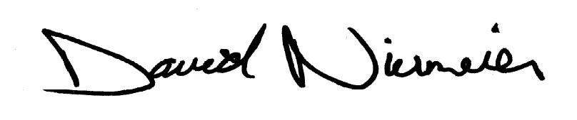
David Niermeier
PYP Music Teacher
niermeierd1@rchk.edu.hk

